# Cogoport UI UX Assignment

Made by:- Aditya Sharan

## Website 1 – dtu.ac.in

1. The colour contrast is not good and that makes the website less appealing to look at.

The colour scheme of the website lacks aesthetic and can be improved upon by using a different colour scheme.

1. The Important Updates section auto scrolls way too slowly.

It needs to go faster, which can be updated easily.

1. Excessive empty spaces on the left and right of the webpage.
2. One button (1st Year Notices) is larger than the others and overlaps with the section below.

The size of the button can be fixed and the overlap can be fixed with z-index.

1. Too many squares and rectangles with sharp edges.

There should be more round boxes or boxes with rounded edges.

Some of the boxes should have rounded edges.

1. Not responsive.

Nothing changes when the resolution is changed. This can be fixed with CSS.

1. Graphics and pictures used are not high resolution.

The pictures and graphics used are not of the correct resolution which makes them look distorted.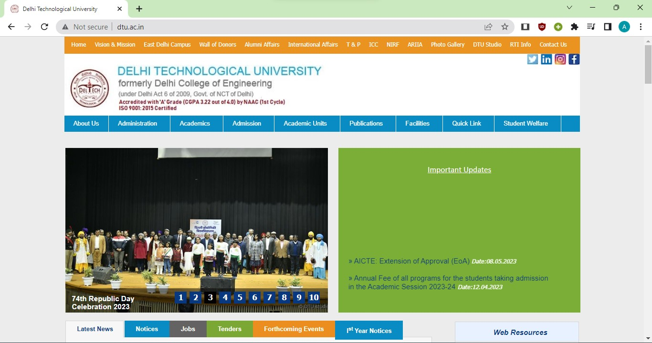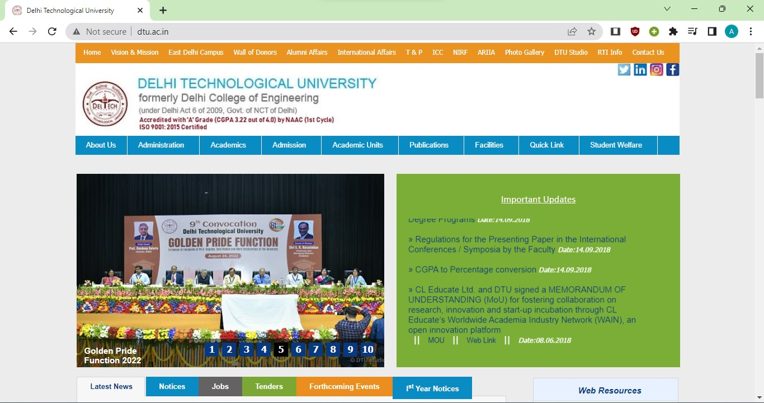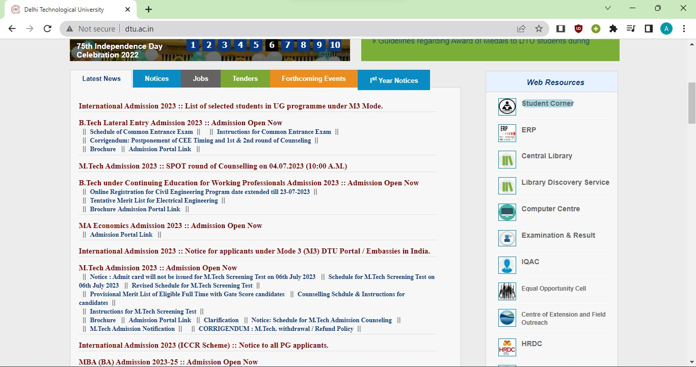

## Website 2 – igdtuw.ac.in

1. Multiple navigation bars.

There should only be one navigation bar.

1. Pictures/graphics are stretched due to wrong resolution.

The pictures and graphics used are not of the correct resolution which makes them look distorted.

1. Too many rectangles and sharp edges.

There should be more round boxes or boxes with rounded edges.

Some of the boxes should have rounded edges.

1. Bland colours/not enough colours.

The website can be made to look better with a more colourful colour scheme.

1. Footer is way too big.

The size of the footer of the website is way too big and should be smaller so that it looks better. 